5 Steps of Writing
Handbook
By: ____________________________

Day 1
The Writing Process
Pg. 12-13

5 Steps of Writing

- _________________
_____________________________________________________________________________________________________________________
- _________________
_____________________________________________________________________________________________________________________
- _________________
_____________________________________________________________________________________________________________________
- _________________
_____________________________________________________________________________________________________________________
- _________________
_____________________________________________________________________________________________________________________

Prewriting

Hello, my name is __________________

Using a glue stick, glue your scribble monster to the black paper given to you by Mrs. Rush.

5 Adjectives to Describe My Scribble Monster
- _______________________
- _______________________
- _______________________
- _______________________
- _______________________

Prewriting Continued

Cluster Diagram

Drafting
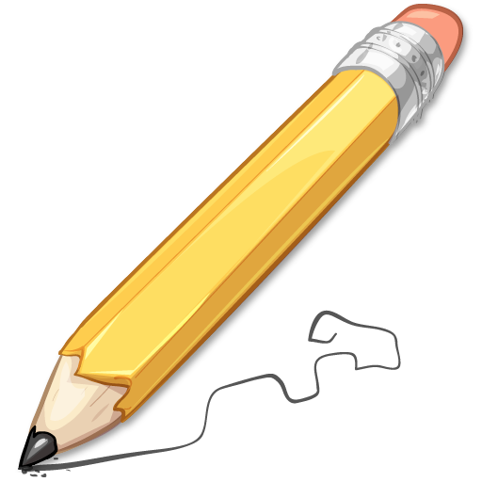
Introduction: Remember: use the cake method. Start big and narrow down to your key ideas.

Big Idea Sentence: ____________________________________
______________________________________________________________________________________________________________
Sentence 2: ___________________________________________
_______________________________________________________
Thesis Statement (State your 3 keys ideas): ___________
_____________________________________________________________________________________________________________________________________________________________________

Soso is a scribble monster from a mysterious place.
He is mentioned in legends but has never been seen by human eyes.
Legends say that Soso had an interesting diet, scary habitat, and very large family.

Drafting

1st Detail Paragraph: Use your first key idea and supporting details from your cluster diagram.

Introduction Sentence (Introduce your key idea. Do not use details.) ______________________________________________________________________________________________________________

Detail #1
______________________________________________________________________________________________________________

Detail #2
______________________________________________________________________________________________________________
Detail #3
______________________________________________________________________________________________________________

Closing Sentence (Restate your key idea. Reword your Introduction Sentence.)
______________________________________________________________________________________________________________

Drafting

2nd Detail Paragraph: Use your second key idea and supporting details from your cluster diagram.

Introduction Sentence (Introduce your key idea. Do not use details.) ______________________________________________________________________________________________________________

Detail #1
______________________________________________________________________________________________________________

Detail #2
______________________________________________________________________________________________________________
Detail #3
______________________________________________________________________________________________________________

Closing Sentence (Restate your key idea. Reword your Introduction Sentence.)
______________________________________________________________________________________________________________

Drafting
3rd Detail Paragraph: Use your third key idea and supporting details from your cluster diagram.

Introduction Sentence (Introduce your key idea. Do not use details.) ______________________________________________________________________________________________________________

Detail #1
______________________________________________________________________________________________________________

Detail #2
______________________________________________________________________________________________________________
Detail #3
______________________________________________________________________________________________________________

Closing Sentence (Restate your key idea. Reword your Introduction Sentence.)
______________________________________________________________________________________________________________

Drafting

Conclusion: Remember: use the cake method- but now turn it upside down. Start narrow with your 3 key ideas repeated and grow your big idea

Restate your 3 keys ideas: ____________________________
______________________________________________________________________________________________________________
Sentence 2: ___________________________________________
_______________________________________________________
Big Idea: _____________________________________________ ______________________________________________________________________________________________________________

Revising
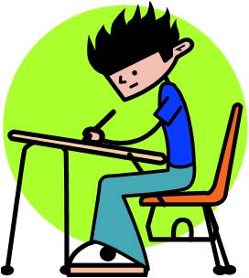

Check for SENTENCE FLUENCY. Use the charts below with each of your detail paragraphs to be sure your sentences flow.

Detail Paragraph #1

Sentence # | # of Words | First 2 Words | Ending Mark
#1
#2
#3
#4
#5

Detail Paragraph #2

Sentence # | # of Words | First 2 Words | Ending Mark
#1
#2
#3
#4
#5

Detail Paragraph #3

Sentence # | # of Words | First 2 Words | Ending Mark
#1
#2
#3
#4
#5

Go through your paragraphs and check for WORDS CHOICE. Use the Thesaurus on the iPad to replace 5 TABOO WORDS that could be more exciting! List the words below that you replaced.

Taboo Word | New Word

Now, check your SENTENCE FLUENCY charts. Do you notice any repetition? If so, make a change!

Self- Editing

Now, we will check our papers for conventions.

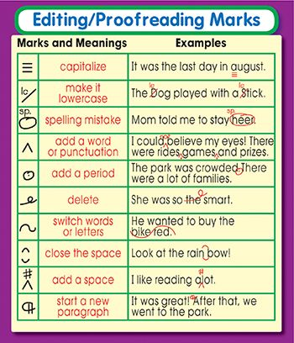

- Using a green colored pencil, check for SPELLING mistakes.

- Using a red colored pencil, check for CAPITALIZATION and PUNCTUATION.

Peer- Editing
Now, you will have your classmate “peer edit” your paper. Please give them this checklist below.

My name is _____________ and I am editing ____________paper.

Please make corrections using a purple colored pencil.

_________ Each sentence begins with a capital letter
_________ Each sentence ends with a punctuation mark
_________ There are no spelling errors
_________ Each paragraph begins with a introduction that does NOT have details
_________ Each paragraph has AT LEAST 3 detail sentences
_________ Each paragraph has a conclusion sentence

Make corrections in their writing for SPELLING and WORD CHOICE. Your goal is to be helpful to your classmate.

